**Lists**

Back in Chapter, you learned how to use the <ul> and <li> elements to create lists with bullet points (also known as unordered lists) and the <ol> and <li> elements to create numbered (or ordered) lists.

In this section you will learn about the CSS properties you can use to control lists.

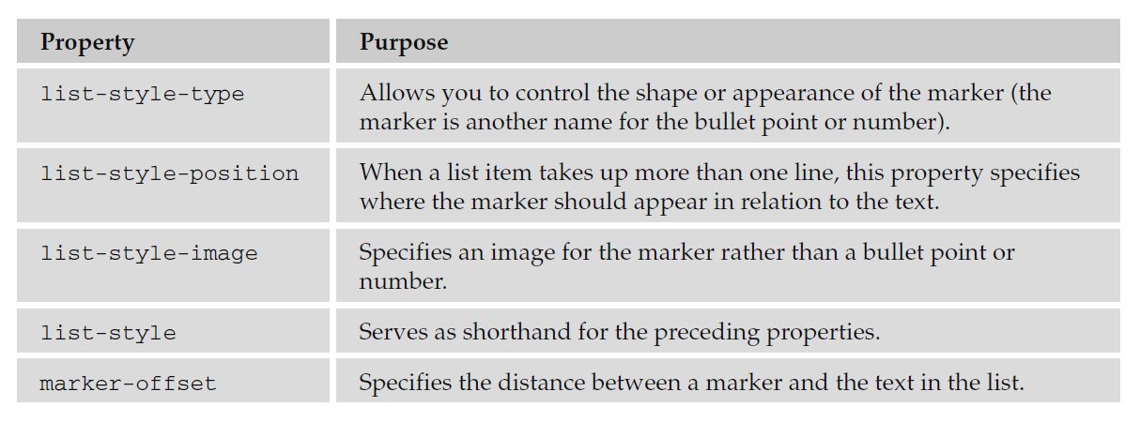

***The list-style-type Property:***

The list-style-type property allows you to control the shape or style of bullet point (also known as a marker) in the case of unordered lists and the style of numbering characters in ordered lists.

The table that follows shows the standard styles for an unordered list.

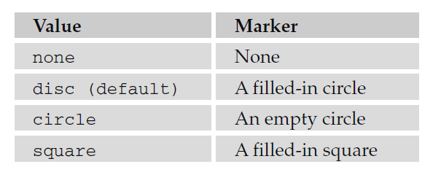

The table that follows shows values for ordered lists that are supported in most browsers.

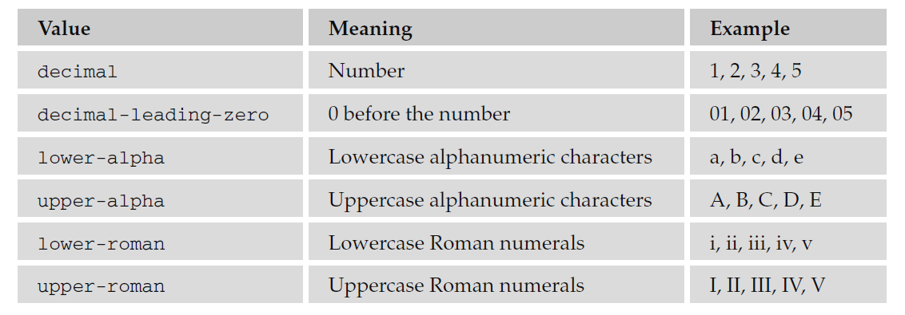

The list - style - type property can either be used on the < ul > and < ol > elements (in which case it applies to the entire list) or on the individual < li > elements. The following example demonstrates all these styles:

li.a {list-style-type: none;}

li.b {list-style-type: disc;}

li.c {list-style-type:circle;}

li.d {list-style-type:square;}

li.e {list-style-type:decimal;}

li.f {list-style-type:lower-alpha;}

li.g {list-style-type:upper-alpha;}

li.h {list-style-type:lower-roman;}

li.i {list-style-type:upper-roman;}

***The list-style-position Property:***

Lists are indented into the page, and the list-style-position property indicates whether the markershould appear inside or outside of the box containing the main points. There are two values for thisproperty, as you can see in the table that follows:

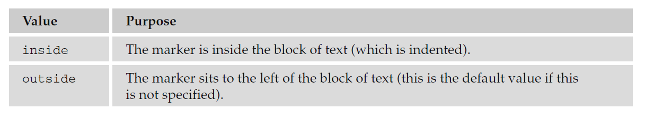

Here you can see how this property is written; in this case it is given on the < ul > or < ol > elements:

ul {list-style-position: outside;}

ol {list-style-position: inside;}

**The list-style-image Property:**

The list-style-image property allows you to specify an image so that you can use your own bullet style. The syntax is similar to the background-image property; the value starts with the letters url and is followed by the URL for the image in brackets and quotation marks:

li {list-style-image: url(“images/bulletpoint.gif”);}

If the image cannot be displayed, the browser should just display a dot rather than a broken image symbol.

*If you are using nested lists, this value will inherit from its parent element. To prevent this from happening, you can use the* list - style - image *property on the nested list and give it a value of* none*.*

***The list - style Property (the Shorthand):***

The list - style property is a way of expressing more than one of these properties at once. They can appear in any order. For example:

ul {list-style: inside circle;}

Remember that you can also set the border, padding, and margin properties for <ul>, <ol>, <li>, <dl>, <dt>, and <dd> elements, as each element as its own box in CSS.